EXPERIMENT – 08
LAPLACE TRANSFORM, INVERSE TRANSFORM, ROC AND STABILITY DATE
DATE: 23.10.2026

OBJECTIVES :
ii) To determine the inverse Laplace transform of a given frequency-domain representation and reconstruct the corresponding time-domain signal.
iii) To determine the Region of Convergence (ROC) of Laplace transforms and analyze its significance in characterizing continuous-time signals and systems.

(ii) Determination of Inverse Laplace Transform for Signal Reconstruction.
PROCEDURE:
- Define X(s) symbolically.
- Apply ilaplace to obtain x(t).
- Evaluate x(t) over 0≤t≤5 s.
- Plot the reconstructed time-domain signal. Observe plot
- Compare the plotted response with the analytical expression.

MATLAB CODE:
MATLAB Coding clc; clear; close all;
Qualitative %% 8(ii) Determination of Inverse Laplace Transform for Signal Reconstruction
figure;
% Inverse Laplace Transform
% Requires Symbolic Math Toolbox
syms s t
X = 1/((s+2)*(s+3));
x = ilaplace(X,s,t);
disp('Inverse Laplace Transform x(t) =');
pretty(x);
tt = 0:0.001:5;
xx = double(subs(x,t,tt));
plot(tt,xx,'LineWidth',1.2);
grid on; xlabel('Time (s)');
ylabel('Amplitude');
title('Signal Reconstructed using Inverse Laplace Transform');

OUTPUT:
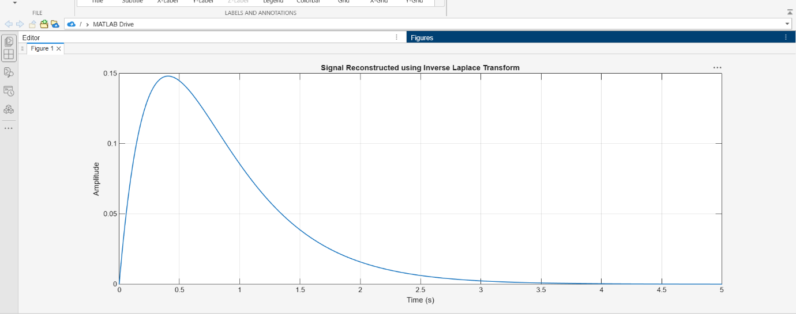

(iii) To determine the Region of Convergence (ROC) of Laplace transforms and analyze its significance in characterizing continuous-time signals and systems.
PROCEDURE:
- Define the pole locations.
- Plot the poles in the s-plane.
- Mark the vertical lines through the poles. Record result
- State the candidate ROC for each signal-sidedness case.
- Interpret the relationship between poles and ROC.

MATLAB CODE:
clc; clear; close all;
%% 8(iii ) Analysis of Region of Convergence (ROC) and Its Significance in System Analysis
figure;
% ROC Analysis for a Rational Laplace Transform
% Requires Symbolic Math Toolbox
% X(s) = 1/((s+2)(s+4))
% Poles are at s = -2 and s = -4.
p = [-2 -4];
plot(real(p),imag(p),'rx','MarkerSize',10,'LineWidth',2);
hold on;
xline(-2,'--'); xline(-4,'--');
grid on; xlabel('Real(s)');
ylabel('Imag(s)');
title('Poles and Candidate Regions of Convergence');
legend('Poles','Pole at -2','Pole at -4');
fprintf('Poles are at s = -2 and s = -4.\n');
fprintf('For a right-sided signal, ROC: Re(s) > -2.\n');
fprintf('For a left-sided signal, ROC: Re(s) < -4.\n');
fprintf('For a two-sided signal, ROC: -4 < Re(s) < -2.\n');

OUTPUT:
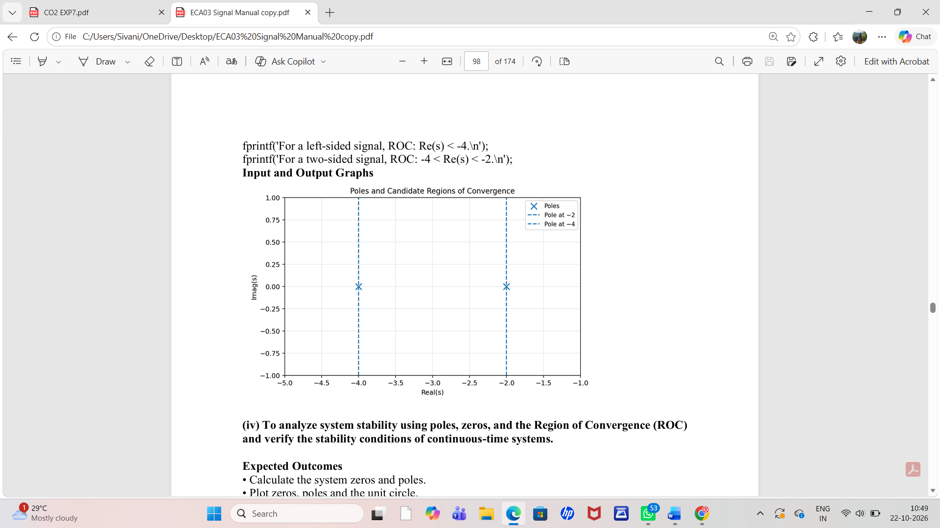

CONCLUSION:
The continuous-time Fourier transform magnitude and phase spectra were analyzed to identify significant frequency components. The time-shift property was verified by comparing the computed and theoretical Fourier transforms, confirming that time shifting preserves magnitude while introducing a frequency-dependent phase shift.

LABORATORY PERFORMANCE ASSESSMENT RUBRICS:
Objective | Assessment Criterion | Excellent – 4 | Good – 3 | Satisfactory – 2 | Needs Improvement – 1 | Weightage | Marks(10) | Marks obtained
(ii) To determine the magnitude and phase spectra of continuous-time signals and analyze their significant spectral components. | Fourier Transform Computation & MATLAB Implementation | Computes X(jω) of every given CT signal correctly, analytically and numerically . Uses a suitable time range, sampling rate and frequency axis in rad/s or Hz. | Computes the spectra correctly, with minor errors in scaling, sampling rate, frequency axis or parameters. | Computes the spectra for only some signals, or has noticeable errors in code, scaling or frequency axis, and needs assistance. | Unable to compute the Fourier transform or produce meaningful spectra. | 20 | 2
 | Magnitude & Phase Spectrum Plots | Plots |X(jω)| and ∠X(jω) correctly for every signal, with proper scaling, titles, axis labels and grid. Handles phase wrapping and phase near zero-magnitude points correctly. | Plots both spectra correctly, with minor errors in scaling, labelling, phase wrapping or axis range. | Plots the spectra with noticeable errors in scaling, phase handling or labelling, and needs guidance. | Unable to plot the magnitude and phase spectra. | 20 | 2
 | Spectral Component Analysis | Correctly identifies dominant frequencies, peaks, bandwidth and the frequency range holding most of the signal energy. Uses symmetry (even magnitude, odd phase for real signals) and relates the spectral lines or lobes to the signal parameters. | Identifies most significant spectral components and bandwidth, with minor errors or limited justification. | Identifies only basic spectral components. Bandwidth or symmetry reasoning is incomplete, and needs guidance. | Unable to identify or justify the significant spectral components. | 20 | 2
 | Analytical vs Numerical Verification | Compares the analytical and MATLAB spectra, quantifies the difference and explains its causes such as truncation, sampling and spectral leakage. Shows how signal parameters change the spectrum. | Compares analytical and numerical results correctly, with brief explanation of differences. | Makes a basic comparison with noticeable errors, and the explanation of differences is incomplete. | Unable to verify the numerical spectra against the analytical results. | 20 | 2
 | Engineering Analysis, Record & Interpretation | Provides technically accurate interpretation of the results and relates them to the physical or engineering meaning of the signal. Maintains a complete, well-organized record with observations, tables, plots and conclusions. | Maintains a proper record with correct interpretation, with minor omissions in explanation or conclusions. | Record and interpretation are partial or only descriptive, and need guidance. | Incomplete record, limited or incorrect interpretation of the results. | 20 | 2
 |  |  |  |  | Total | 100 | 10

